**ANIMAL CLASSIFICTON**

**Classification of Animals**

**Carlous Linnaeus**, who is usually regarded as the founder of modern taxonomy and whose books are considered the beginning of modern botanical and zoological nomenclature.

He proposed that there were three broad groups, called kingdoms, into which the whole of nature could fit. These kingdoms were animals, plants, and minerals. He divided each of these kingdoms into classes. Classes were divided into orders. These were further divided into genera (genus is singular) and then species. We still use this system today, but we have made some changes.he father of modern taxonomy, Carl Linnaeus, classified animals based on observable characterestics.

**Linnaean system of classification:**

* The Linnaean system of classification consists of a hierarchy of graded taxonomic (named) ranks that are called as **taxa**.
* Any given **taxon**(singular) may contain several lower taxa, which can be usually distinguished based on certain common characteristics.

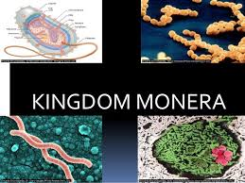**Kingdom Monera**

1. They are small, simple single prokaryotic cell (nucleus is not enclosed by a membrane); some form chains or mats
2. They can absorb food and/or do photosynthesis.
3. Eg. bacteria, blue-green algae (cyanobacteria), and spirochetes.

**Kingdom Protista**

1. They are single eukaryotic cell (nucleus is enclosed by a membrane); some form chains or colonies
2. They absorb, ingest, and/or photosynthesize food
3. Eg. protozoans and algae of various types

**Kingdom Fungi**

1. They are multicellular filamentous form with specialized eukaryotic cells.
2. They absorb food
3. Eg. Mosses, Moulds, Yeast

**Kingdom Plantae**

1. 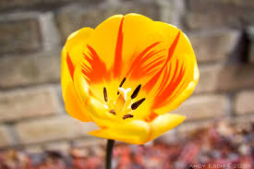They are multicellular form with specialized eukaryotic cells; do not have their own means of locomotion
2. They photosynthesize food
3. Eg. mosses, ferns, woody and non-woody flowering plants.

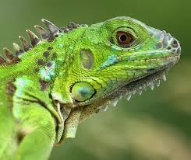

**Kingdom Animalia**

1. Multicellular , eukaryotes
2. Tissue specialization
3. Areobic
4. Heterotrophs (ingest organic material)
5. Have no cell wall
6. Can move (move at some point in life
7. Sexual Reproduction
8. Occur in variety of habitat

**Animals can be classified on basis of following:**

**1) Levels of organization :**-

* + **Cellular level**:

eg: Sponges

* + **Tissue level**:

eg: Ceolentrates

* + **Organ Level** :

eg:Platyhelminthes

* + **Organ System level**:

eg:Annelids, Arthopods, Mammals, etc

**2) Symmetry**

Asymmetrical

Radial

Bilateral

**3) Ceolom**

Ceolomates:-Arthopod, chordate

Pseudoceolomates:- Aschehilminthes

Aceolomates:- Platyhelminthes

**4) Vertebral column:**

* Vertebrates- have a backbone
* Invertebrates- Do not have a backbone.

**Vertebrates**:

* These are animals with a backbone.
* **There are five groups of vertebrates:**
  + **Fish**
  + **Amphibians**
  + **Reptiles**
  + **Birds**
  + **Mammals**

**Fish**

* Are cold-blooded.
* Live in water
* Lay eggs (but some do give birth to live young).
* Have a moist skin covered in scales.
* Breathe through gills.

**Amphibians**

* Are cold-blooded.
* Lay eggs.
* Have a smooth, moist skin.
* Are able to live on land as well as in the water.

**Reptiles**

* Are cold-blooded.
* Lay eggs.
* Have a dry skin covered with scales.

**Birds**

* Have feathers and hollow bones
* Lay hard shelled eggs
* Warm blooded

**Mammals**

* Have hair and produce milk
* Give birth to live offspring (no eggs)
* Warm blooded

**Invertebrates:**

* These are animals without a backbone
* They breathe through their skin and reproduce by laying eggs.
* **There are three broad groups of invertebrates**:
  + **Worms**
  + **Molluscs**
  + **Arthropods**

**Worms**

* Have round or flat bodies
* Generally have bodies divided into segments
* Breathe through their skin

**Molluscs**

* Crawl on a single fleshy pad.
* Breathe through their skin
* Can have a shell

**Arthropods**

* Have lots of legs and segmented bodies.
* **There are four group of arthropods:**
  + **Spiders**
  + **Centipedes & Millipedes**
  + **Crustaceans**
  + **Insects**

**Spiders**

* Have four pairs of legs.
* Have bodies divided into two sections

**Centipedes & Millipedes**

Have long thin bodies and pairs of legs on each of their many body sections

**Crustacean**

* Have five-seven pairs of legs
* Bodies covered in shell

**Insects**

* Have three pairs of legs
* Bodies divided into three sections
* Often have wings .